# **Making proper and assertive language expressions:**

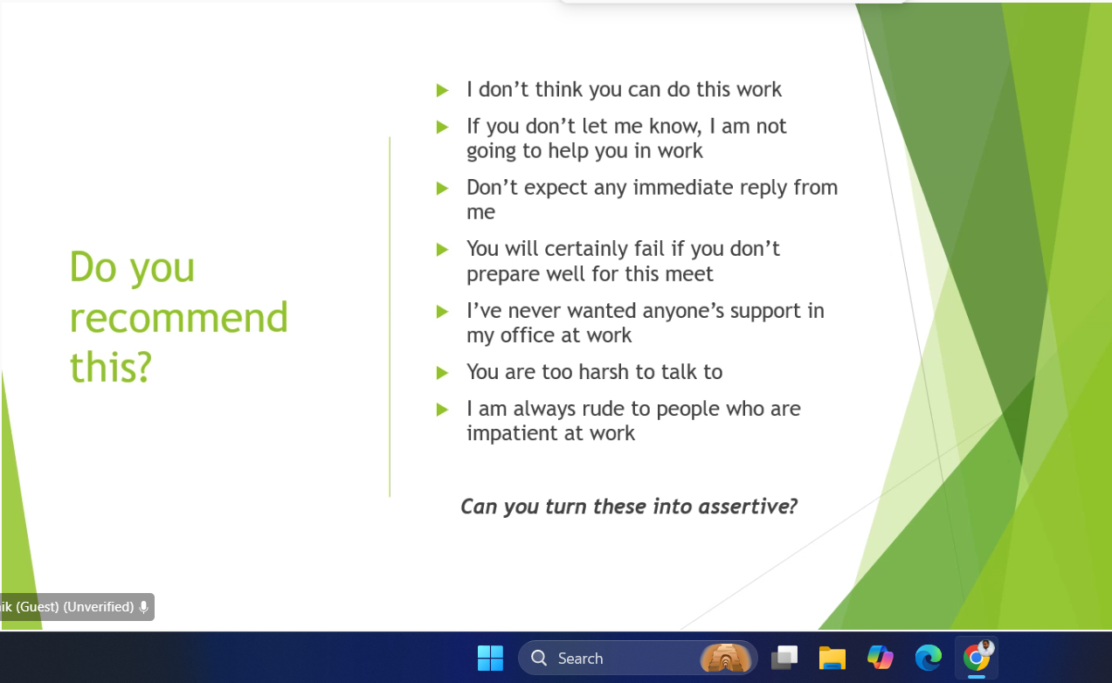

1. I think you can do this work only when you collaborate with any AI expert.
2. If you let me know clearly then I can help you and will keep this confidential.
3. Kindly expect some delay in my reply throughout today.
4. Please expect some delay in responses from me for next two days as I am going through full day training sessions.
5. I have experience of handling similar tasks so I can do this alone.
6. I prefer working independently and generally don’t rely on others for support.
7. If we are polite with others, then we can seek quick and positive responses.
8. I am always polite and supportive to people who show patience at work.

We should monitor and modify our expressions be it oral or written to sound assertive and polite because communication is an interpersonal skill. The chances of these three elements are very high:

1. Misunderstanding
2. Misinterpretation
3. Miscommunication

# **Soft and Hard elements for a movie:**

**Movie name:** Kalki (Prabhas)

Soft Skills:

1. Presence on Screen: Prabhas has a strong and appealing presence that grabs the audience's attention.
2. Emotional Acting: He’s great at showing emotions in his acting, making his character feel real.
3. Teamwork: He works well with other actors and the film crew to create a great movie experience.

Hard Skills:

1. Action Skills: Prabhas performs exciting and well-choreographed action scenes in the movie.
2. Physical Transformation: He works hard on his fitness to fit the role and look he needs.
3. Strong Dialogue Delivery: He delivers his dialogues clearly and powerfully, making his character more believable.

**Movie name:** Game of Thrones

Soft Skills:

1. Leadership: Jon Snow and Daenerys inspire loyalty and make tough decisions to lead armies and nations.
2. Strategic Thinking: Tyrion and Littlefinger outthink opponents, using clever strategies to gain power.
3. Emotional Intelligence: Sansa and Cersei read emotions well, using them to manipulate situations to their advantage.

Hard Skills:

1. Combat Skills: Jaime, Arya, and Brienne are exceptional fighters, excelling in swordplay and battle.
2. Political Maneuvering: Tyrion, Cersei, and Varys manipulate people and situations to secure power and control.
3. Survival Skills: Jon Snow and Sandor Clegane survive harsh conditions, using their strength and resourcefulness.

**For example:** If you watch Youtube videos like Vlogs on Food or Travel or Education

* The ability of the presenter to gather information, communicate through verbal and non-verbal is Soft element while the video is also attractive due to some other reasons like editing, infographics, audio settings, pictographics, clarity settings, etc. which is Hard element. So, now tell me friends, is it not important for a professional to have both soft and hard skills to be competent in this world?

**My answer:**

* Yes, it is essential for professionals to have both soft and hard skills to excel in today's world. Soft skills like communication and presentation build connections, while hard skills like technical expertise, editing, and design ensure quality output. Together, they create a powerful and impactful professional presence.

# **Conversation:**

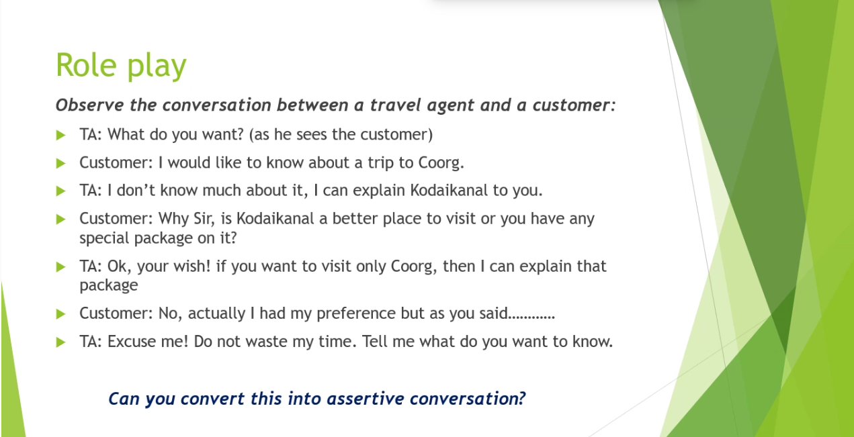

Effective conversation have below skills:

* Probing skills
* Patience
* Politeness
* Empathy
* Customer need analysis
* Business ethics
* Selling skills

My conversation in assertive manner:

***TA:*** Welcome sir, how can I help you?

***Customer:*** Hello, I would like to know about a trip to Coorg.

***TA:*** Sorry sir, unfortunately I didn’t know much about that. But I can explain Kodaikanal if you’re interested.

***Customer:*** Why sir, is Kodaikanal a better place to visit or you have any special package on it?

***TA:*** If you want to continue with Coorg, just give me a moment, I can explain that package.

***Customer:*** No, actually I had my preference but as you said continue with Kodaikanal.

***TA:*** That’s a great choice sir, we are providing 10% discount for you. Thank you for choosing us, have a nice day.

***Customer:*** Thanks for the suggestions.

# **Qualities of Good Communication:**

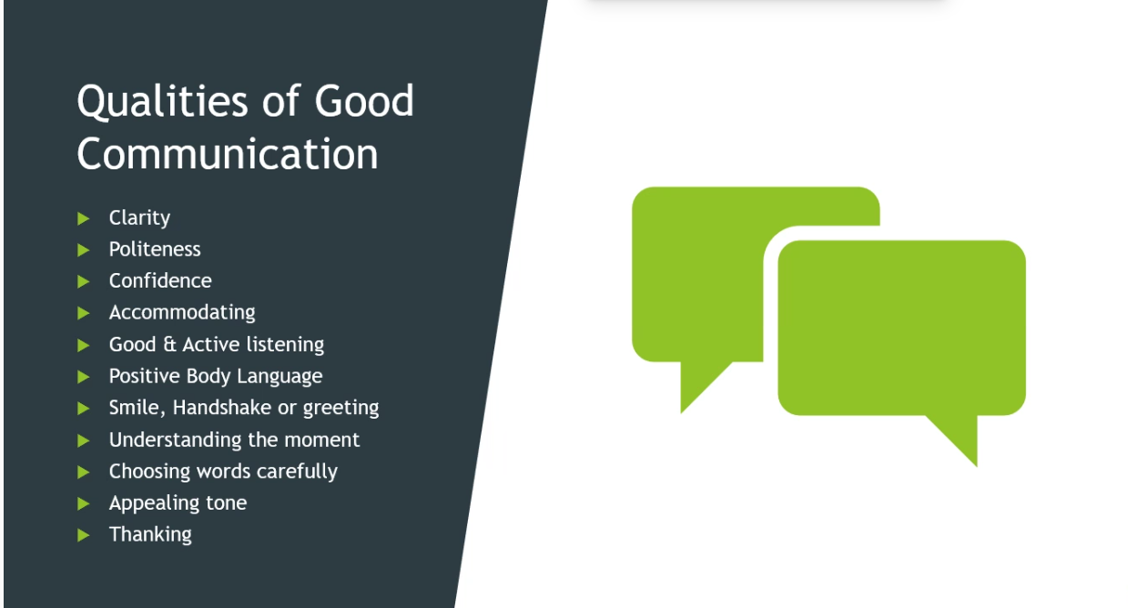

What are the various elements of Verbal communication? Write 5 - 7 points in a single message and post here. Please post only points and strictly no paragraphs.  Time limit to post: 7-8 mins. Do not write more than one message. All must post the comments here. Eg: Voice.

**From me:**

1. Voice tone and modulation
2. Choice of words
3. Clarity and pronunciation
4. Pitch and volume
5. Pace or speed of speech
6. Non-verbal cues supporting verbal communication (e.g., pauses)
7. Grammar and sentence structure

**From Sir:**

The various elements of Verbal communication are:

1) Language   
2) Pitch   
3) Volume   
4) Pronunciation   
5) Accent   
6) Modulation   
7) Stress of words  
8) Dialect   
9) Overall clarity  
10) Words   
11) Feedback   
12) Polite tone  
13) Fluency  
14) Subject knowledge   
15) Probing  
16) Empathy  
17) Active listening

**Various Elements of Verbal Communication**

1. **Language Skills**: Including vocabulary, pronunciation, accent, dialect, slang, fluency, sentence building, idioms, proverbs, anecdotal style, and abbreviations used in speaking.
2. **Voice**: Tone, speed, volume, and clarity of the speaker's voice are essential for effective communication.
3. **Confidence**: Being confident about the topic being discussed and ensuring the voice is audible to everyone.
4. **Listening Skills**: Active listening is crucial for understanding and responding appropriately to messages.
5. **Patience and Attention to Detail**: Important qualities for effective communication.
6. **Grammar and Vocabulary**: Correct usage of words, spelling, and speaking concisely.
7. **Persuasion Skills**: Ability to persuade others through verbal communication.
8. **Clarity and Conciseness**: Clear expression of ideas and speaking succinctly to avoid confusion.
9. **Knowledge about the Topic**: Having enough knowledge about the topic being discussed.
10. **Attitude**: A positive attitude can influence the effectiveness of verbal communication.
11. **Politeness**: Being polite and respectful in interactions enhances the quality of verbal communication and fosters positive relationships.

***Verbal Communication also involves Effective listening/Active listening. It means having the ability to follow the steps stated below:***

***Listening - Understanding - Storing - Retrieving – Aligning - Expressing.***

***It is required not only for audio clips but for all the following situations like***

***Meetings, Conversation, Discussion about the project or technology, KT sessions, Training, Telephonic conversations etc.***

***Note-making:***

***Note-making is the most important aspect of storing data while listening as part of Verbal communication.***

***Paraphrasing:***

***Paraphrasing means listening and expressing using your own words but not allowing any loss of information or at least the theme of the information listened to.***

***Note making and Paraphrasing through Listening-Understanding-Storing-Retrieving-Aligning-Expressing are very important.***

***Sender-Message-Receiver-Feedback - The process of communication.***

***If anyone faces difficulty in expressing building proper sentences though they have proper thoughts in mind; they should write down 5 - 7 lines in a book and read them and practice so that you get a smooth flow. This is an important activity to pick up skills.***

Types of communication and practice:

For building Verbal communication, we need to give enough exercise to our tongue in pronouncing words and sentences regularly.

For Non-verbal communication, we need to practice speaking in front of people like on stage or in virtual meetings clearly without fear and make improvements.

Also practice developing infographics, ppts, graphs, pie charts, bar charts, symbols pictures or any sign-based communication in your presentation.

Keep writing your thoughts clearly in mails, essays, note books, or in any electronic form and proofread the same.

Make use of resources/equipment/infrastructure like training rooms, conference halls, projector, pointers, flip charts, writing boards, markers, stage, podium, notes, notepad or any electronic means of reference material during presentation.

What are the various elements of Non-verbal communication. Write 5-7 points each of you here in a single block of message. All must do. Time limit: 4-5 minutes. Eg: Eye contact. This time, do not commit the mistakes that you committed in the morning. Please start your activity.

The various elements of Non-Verbal communication are:

1. Facial expressions   
   2. Gestures  
   3. Posture  
   4. Eye Contact  
   5. Head Movements  
   6. Personal Space (Proxemics)  
   7. Physical Proximity  
   8. Touch (Haptics)  
   9. Tone of Voice (Paralanguage)  
   10. Pitch  
   11. Volume  
   12. Speaking Rate  
   13. Pauses  
   14. Clothing and Attire  
   15. Accessories  
   16. Grooming  
   17. Punctuality (Chronemics)  
   18. Response Time  
   19. Time Spent

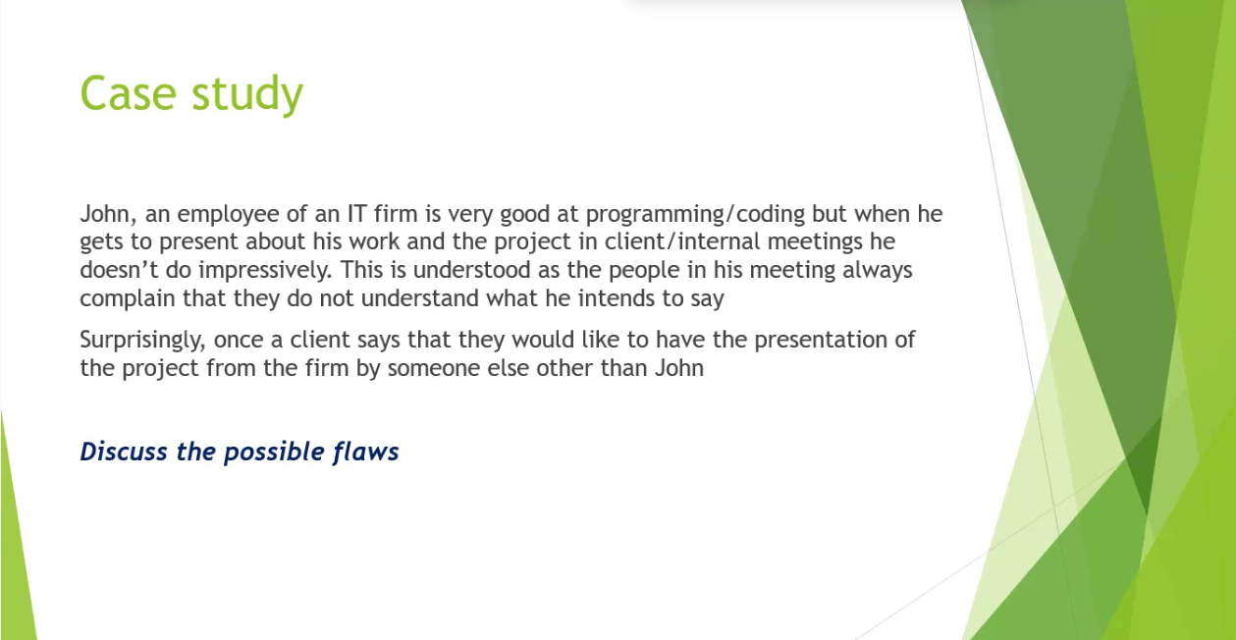

1. Lack of Audience awareness
2. Poor structure and clarity
3. Ineffective Delivery Style
4. Lack of Empathy for the Audience
5. Limited Confidence

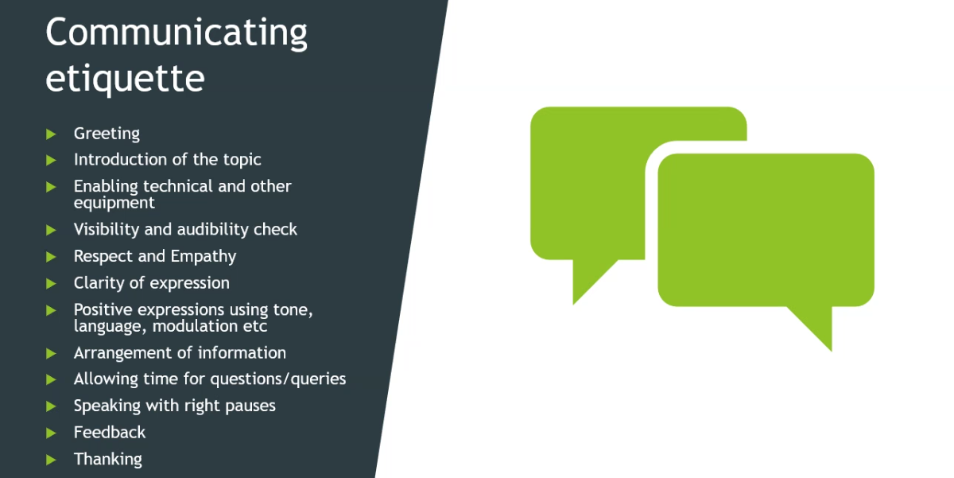

* In Verbal communication, Affirmative modulation, Interrogative modulation and Exclamatory modulation are very important. Read the following with correct modulation:
* Writing? Writing! Writing.
* Modulation is very important in verbal communication.
* Modulation is nothing but the rise and fall of voice during speech.
* It is also called intonation.
* One word also can produce modulation and can send your intention clearly to your listener.